Birla Institute of Technology & Science, Pilani
Work Integrated Learning Programmes Division
First Semester 2020-21
M.Tech. (Data Science and Engineering)
Comprehensive Examination (Makeup)

SOLUTION

Course No. : DSECLZG524
No. of Pages = 5

No. of Questions = 5
Course Title : DEEP LEARNING
Nature of Exam : Open Book
Weightage : 50%
Duration : 2 Hours
Date of Examination : November 21, 2020 Time of Exam:
Note: Assumptions made if any, should be stated clearly at the beginning of your answer. Show your rough work to get partial credit, when appropriate.

Question 1. [3+1+1=5 marks]

- For a newsfeed classification system with 46 topics, the following two models are tried. 10,000 unique words are used as input in both models. 20% of the training data is used as the validation set, partial_x_train. What is the number of trainable parameters in the input-hidden layer and hidden-output layer in Model 2? Which of the networks will give lower validation error and why?

Network Model 1  model = models.Sequential()  model.add(layers.Dense(64, activation ='relu', input_shape =(10000,)))  model.add(layers.Dense(64, activation ='relu'))  model.add(layers.Dense(46, activation ='softmax'))  model.compile(optimizer='rmsprop',loss='categorical_crossentropy ’, metrics =['accuracy']) model.fit(partial_x_train, partial_y_train, epochs=9, batch_size=512, validation_data =(x_val, y_val)) | Network Model 2  model = models.Sequential()  model.add(layers.Dense(64, activation = 'relu', input_shape =(10000,)))  model.add(layers.Dense(4, activation ='relu'))  model.add(layers.Dense(46, activation ='softmax')) model.compile(optimizer='rmsprop',loss='categorical_crossentropy', metrics =['accuracy'])  model.fit(partial_x_train, partial_y_train, epochs=20, batch_size=128, validation_data=(x_val, y_val))

# of trainable parameters in the input-hidden layer: 10000*64+64=640064
# of trainable parameters in the hidden-output layer: 4*46+46=230
Model 2 will give less validation error since hidden layer 2 is too small leading to information loss and reduced generalization ability.
- The following two networks use different L2 regularization constants. Which of the validation Loss curves (indicated by ‘+’ and ‘.’) correspond to Network 1 and Network 2 models?

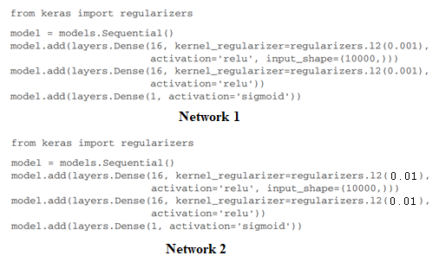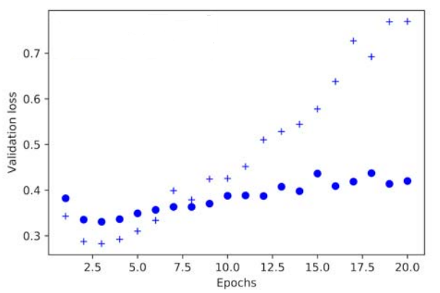

Network 2 corresponds to lower validation loss curve ‘.’, due to higher generalization arising from higher L2 constant.

- For a sentiment classification system, the following two models are tried. 10,000 unique words are used as input in both models. 20% of the training data is used as the validation set. Which of the following validation loss curves (indicated by ‘+’ and ‘.’) correspond to Network model 1 and 2?
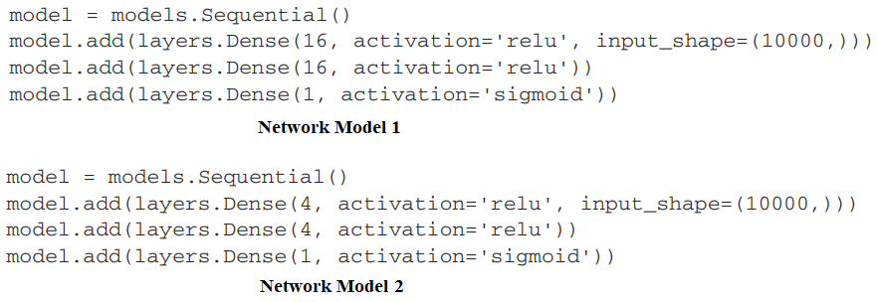

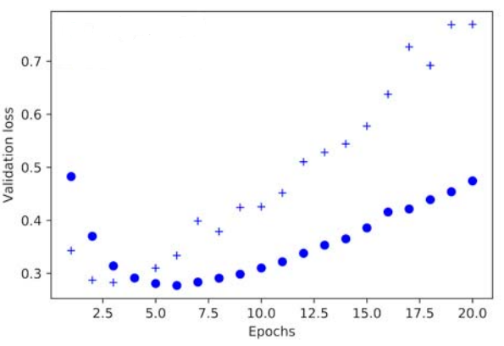

Network 1 gives higher validation loss ‘+’ due to overfitting with larger number of hidden nodes.

Question 2. [2+4+1=7 Marks]

Build a minimal two hidden layer network with step activation that realizes the following decision boundary and specify all the weights and bias. For step activation function, output is +1 if total input >= bias T else output is -1.

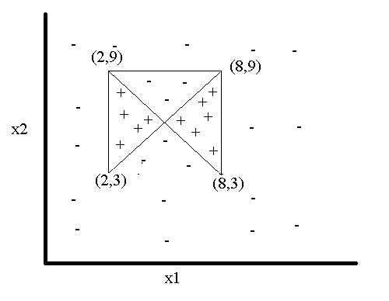
- Draw the network architecture. What is the minimum number of hidden nodes required at hidden layer 1 and hidden layer 2?
Number of hidden units in hidden layer 1 = 4, number of hidden units in hidden layer 2 = 2.
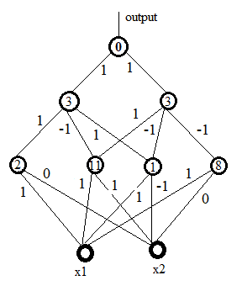
Note other combination of weights and bias values also possible.

- Specify all the weights and biases. Weights can be only -1, 1 or 0 only.
- Can this decision boundary be realized with one hidden layer? If yes, how many hidden nodes will be required?
Due to two disjoint decision regions, two hidden layers are needed. If one hidden layer is used, infinitely large number of hidden units will be needed.

Question 3. [1+1+2+3+2=9 Marks]
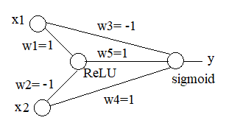

Hidden node and output node use, respectively, ReLU and sigmoid activation functions.
Bias values at hidden and output nodes are zero. Weights for the current iteration are given in the above figure. Target output d is specified as 0. Learning rate is 0.3.
- Calculate the actual output y for the current iteration with input (x1, x2) = (1, 1).
y=1/(1+1)=1/2
- Calculate the binary cross-entropy error for the current iteration.
L= - (1-log(1/2))=-1-log(2)
- Assuming L1 regularization constant = 0.2, calculate the new w₃ for the next iteration.
Let z be the total input to the output node. y=1/(1+exp(-z))
w3(t+1)=w3(t)-0.3*dL/dw3-0.2*0.3*sign(w3)=-0.94-0.3*dL/dz*dz/dw3
= -0.94-0.3*x1*1/2*1/2=-0.94-0.3/4
- Assuming L2 regularization constant = 0.2, calculate the w₁ for the next iteration.

Let h1 be the output of the hidden node.
w1(t+1)=w1(t)-0.3*dL/dh1*dh1/dw1-0.3*0.2*w1=0.94, since dh1/dw1=ReLU’(0)=0
- Assuming both L1 (with regularization constant=0.2) and L2 (regularization constant=0.2) are applied, calculate the value of w5 in next iteration.
w5(t+1)=w5(t)-0.3*dL/dz*dz/dw5-0.3*0.2*w5-0.3*0.2*sign(w5)=0.88

Question 4. [1+1+1=3 marks]

- What is a saddle point? What is the advantage/disadvantage of using Stochastic Gradient Descent in dealing with saddle points?
In a multi-dimensional surface, points where all the partial first derivatives are 0 but some of the partial double derivatives are +ve and some are –ve are known as saddle points. Or in other words, Hessian is –ve definitive. At Saddle points, the surface has one or more minima along some directions and maxima along other directions.
- Figure below shows how the cost decreases (as the number of iterations increases) during training. What could have caused the sudden drop in the cost? Explain.
Due to drop in learning rate.
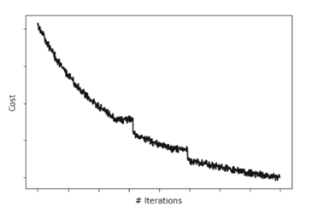
- What are five strategies to prevent overfitting in deep networks, when used for classification, say of images?
L1/L2 regularization, dropout, data augmentation, early stopping, adding noise to input/target output.
Question 5. [1.5+1.5+1+2=6 Marks]

The training data and network architectur0.e are given below. Sigmoid activation function $y(z)=\frac{1}{1+e^{-z}}$ is used at the output node and binary cross-entropy is the loss function. Learning rate is 0.25 and momentum rate is 0.75. (w0, w1) at iteration t=4 is (0, 0) and at iteration t=5 is (-1, +1). Batch training is used.

Input x | Target Output d
0 | 0.0
1 | 1.0

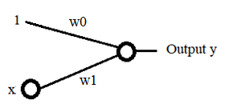

  - Calculate the value of training loss at t=5.
L = - (1-log(1/1+exp(-w0))-log(1/(1+exp(-w0-w1))
= -1-log(1+exp(-w0))+log(1+exp(-w0-w1))
=-1-log(1+e)+log(2)
  - Calculate the gradient of the training loss function at t=5
(dL/dw0, dL/dw1)=(-1/2+e/(1+e), -1/2) for (w0,w1)=(-1,1) at t=5
  - Calculate the new values of w0 and w1 at iteration t=6 when momentum based gradient descent is used.
w0(6)=w0(5)-0.25*(-1/2+e/(1+e))+0.75*(-1.0)=-1.75+0.125-0.25e/(1+e)
w1(6)=w1(5)-0.25*(-1/2)+0.75*1=1.125+0.75=1.875
  - Calculate the new values of w0 and w1 at iteration t=6 when Nestorov accelerated gradient descent is used.
(dL/dw0, dL/dw1)=(-1/2+exp(1.75)/(1+exp(1.75)), -1/2) for (w0,w1)=(-1.75,1.75)
w0(6) = -1.75-0.25*(-1/2+exp(1.75)/(1+exp(1.75))
= -1.75+0.125-0.25*exp(1.75)/(1+exp(1.75)
w1(6)=1.75-0.25*(-1/2)=1.875

